An applet is a java plug-in for a browser where a java application is a standalone program that does not require a GUI or Web browser and can be a very powerful engine for a variety of computational needs. We’ve mostly worked/played with Java applications, thus far.

Here’s an example of an Applet that I built:

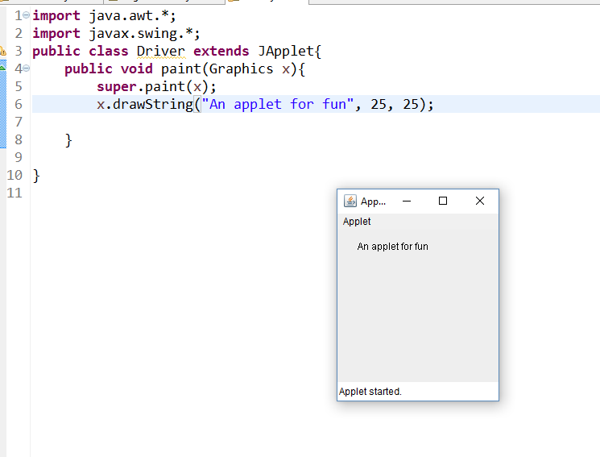

You can also embed an applet right into a web page by using <embed> or <object> tags in HTML5; earlier versions support <applet>. Here’s what that code could look like.

